LEGALREQST Garnishments

Purpose
This procedure details the Garnishee activities required when A request is received from DS Contracting.

Background
Garnishee (LEGALREQST work type in AWD Chorus) requests are received when the government (Canada and Quebec) requests to start or stop a garnishment for an advisor. When a garnishment is placed on an advisor, all or a percentage of commissions generated are directed to the government via cheque to satisfy the advisor’s debt. On occasion we may receive requests for information regarding a garnishee.
Requests will only be received for individuals. Corporations cannot be garnished.

Documents Required
- The email from DS Contracting
- This will include the original request they received from the Government.
- Garnishee List or NAAD Listing
- Located on the shared drive: I:\Commissions\GARNISHEE FOLDER
System Required
- Capsil
- CAMS
- Excel
- Access to the Commissions’ team shared drive

​

STEP ACTION
​1 ​Log in on AWD Chorus and search for the LEGALREQST CSD.
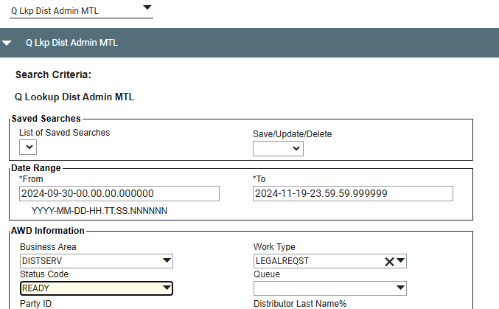

​2. ​Open the CSD and review documentation.
- Subject of the request usually is “Garnishment – [Advisor name]”
- Request from federal (Canadian) or provincial (Quebec) government is attached in pdf format
- Ensure the date on the pdf is current. Contact DS Contracting if the date is not current.
- Details of the request to look for (for new garnishee set-up request)

IF | THEN
Advisor Name | Required
SIN, DOB | Optional
Remittance Rate (%) | Federal: Required  Quebec: if no rate is provided  Default is 100%
Total amount to be remitted.  (maximum payable) | Required
Payee name and address. | Required
Payment details to include on NAAD (which show up on cheque stub): i.e. advisor name and garnishee reference number, etc. | Optional – Usually for Quebec

​
IF | THEN
​Documentation is complete, and all requirements are in order, | ​Proceed to next step.
There are outstanding requirements, | ​Email DS Contracting (include the attachment) and request additional information, such as SIN number.

​3 Determine if the advisor has eligible SL codes.
ALL Standard Life (SL) codes must be found for the advisor:
- Using CAMS and ALPH, do a search using the advisor’s name.
**Note: Attention should be given to possible name variations. Example: John - Jack, Daniel – Dan; Elizabeth – Betty.
IF | THEN
​No SL codes can be found that match the advisor’s name and SIN/DOB, | ​Email the requester and add a comment (No SL codes found) to the case in AWD then mark as PROCESSED.
​SL codes are found, | Determine whether they are eligible for garnishment.  ​SL Codes Eligible for Garnishee ​SL Codes to Exclude  ​ACTIVE vested advisors ​Terminated codes  ​​Capsil-MTL: all ​Corporate codes  ​Capsil-CRO: S-codes and true CRO codes, meaning numeric CRO codes ​NVEST codes (no commissions paid to individual)  ​F-branch codes (Fundserv branches, e.g. F3162 – these codes are obsolete)  ​Capsil-CRO: Z-codes (no commissions paid)

​If ... | ​Then ...
​YES, Eligible for Garnishee | Proceed to Step 4
NO | - SL code is not eligible for Garnishee  - Fill out the necessary information in LEGALREQST CSD then add a comment and change the status to PROCESSED.

4 Note all the ACTIVE codes. Validate on the client listing if there is any business with us.
​If ... | ​Then ...
​YES | Proceed to Step 5
NO | NOTE: If the SL code has no business but linked to an ACTIVE Manulife selling code: Sent an email confirmation to Sr. Analyst (Anto) before to proceed.  - Clone for TRMINATION CSD- Add a comment.  - Applying Garnishment is not required.  - Fill out the necessary information in LEGALREQST CSD then add a comment and change the status to PROCESSED.

​5 Log in on CAPSIL.
Check the eligible SL codes to see whether they have an active garnishee (this will help you determine which type of action you will have to take)
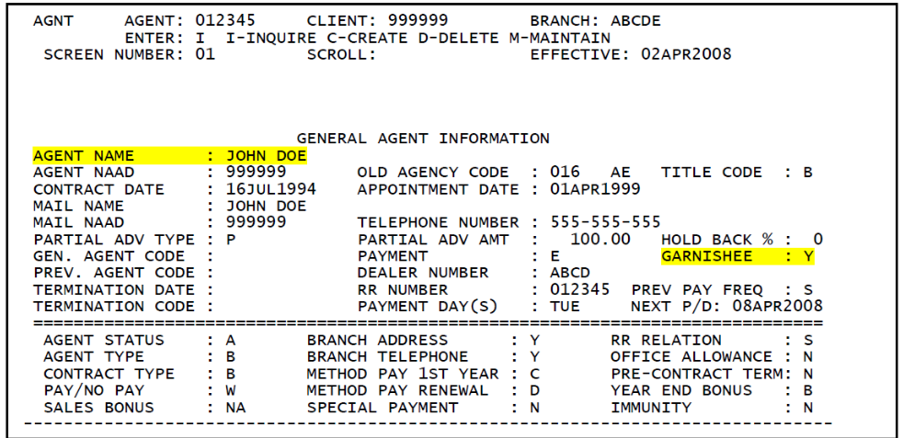

- N = Broker is not being garnished.
- Y = Broker is being garnished.
When Matching SIN:
- Once a Matching SIN is done, if there is a broker code that shows the Producer Name as a Company, this code should be reviewed to determine if a Garnishee is applicable.
- If the company has an “Ltd” or “Inc”, that code cannot be garnisheed.
- If a company does not have Ltd or Inc, we must contact DS and advised them. They will come back with further instructions on how to proceed. (In other words, the company has a name like ABC Shoes.)

​6 ​Determine type of Garnishee request & process accordingly. Scroll down for more details for the list below:
- Set-Up a New Garnishee
- Modify an Existing Garnishee
- Release (Stop) a Garnishee
- Request for information
- Release on CRO Capsil

Set-Up a New Garnishee

Step | Action
1 | Log-in on Capsil and Go to AGNT Screen 01.  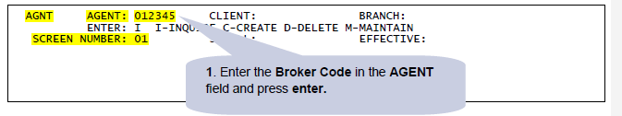
2 | Validate the AGENT NAME on the AGNT screen, if the same on the request.  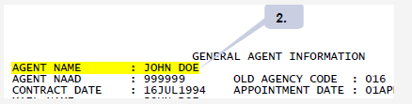
3 | In the ENTER field, type M and press enter:  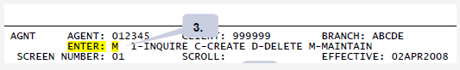  - I-INQUIRE (Default, to view information on an existing client)  - M-MAINTAIN (To change or add information on existing client)
4 | In the Garnishee field, modify the N to Y and press enter:  - N= Broker is not being garnished.  Y= Broker is being garnished.  **Note: There is a maximum of 3 garnishees that can be applied to an advisor and a maximum of 6 advisor codes that can be garnished at one time.
5 | - ​Open the NAAD Listing for Garnishees  - I:\Commissions\GARNISHEE FOLDER\Garnishee Tracker  - Confirm if a Client Number (NAAD record) already exists for the Client name, i.e. Receiver General for Canada.  **Note: Revenue Canada – Commonly used NAADS:  - Ottawa: 958725  - Sudbury: 980727  Quebec: Usually, you will need to create a new NAAD due to unique reference number and/or name of case handler (“Responsable” or “Personne-ressource” in French)  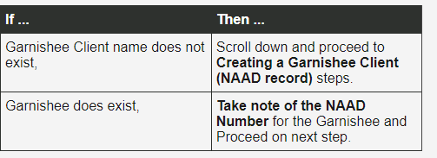
6 | Change the SCREEN NUMBER filed of the Capsil to 02 and press enter. In the ENTER field type M and press enter:  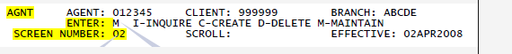
7 | Enter the required information under the GARNISHEE #1 Fields:  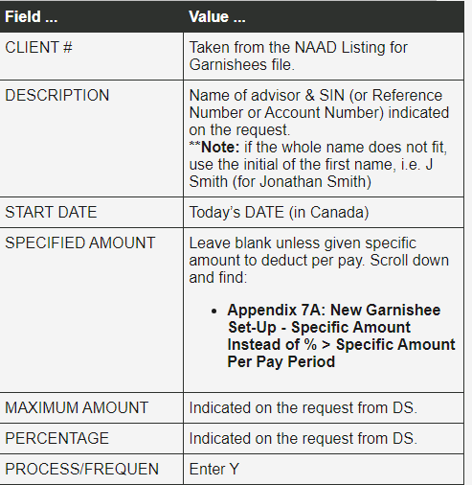
8 | Send confirmation email to DS Contracting:  FROM: SALES ADMIN MAIN  TO: DS CONTRACTING  SUBJECT: RE: GARNISHMENT- [ADVISOR NAME]  ATTACHMENT: Keep pdf attached  EMAIL BODY:  Hello,  The garnishment has been activated for [ADVISOR NAME],  SL code(s) [CODE-BRANCH].  Thank you,  [your signature]
9 | ​Finalize case in AWD:  - Attach confirmation email to CSD  - Add comment: “Activated garnishee”  - Ensure at least advisor First Name, Last Name, SL Code and Branch Code are completed.  - Change status of CSD to PROCESSED.  - If you have more than 1 SL code, create a briefcase and clone CSD in order to have 1 CSD per code.

​Modify an Existing Garnishee

Step | Action
1 | Log-in on Capsil and Go to AGNT Screen 01.  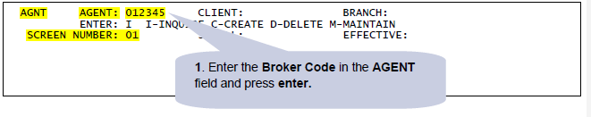
2 | ​Validate the AGENT NAME on the AGNT screen, if the same on the request.  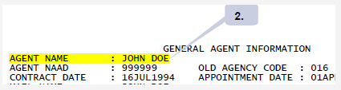  (Also use NAAD 01 to validate SIN matches government document)  - If the information does not match:  - Make sure the code was entered correctly.  - If it does not match- reply to DS and advise.  Make sure the Garnishee is set to Y:  - N = Broker is not being garnished.  - Y = Broker is being garnished.
3 | Change the SCREEN NUMBER field to 02 and press enter.  - Take the screen shot of AGNT Screen 02 before modifying any information to have a record of the value in the ACCUMULATED TOTAL field. Save and attach to CSD in AWD.
4 | In the ENTER field type M and press enter:  - I = Inquire (Default, to view information on an existing client)  - M = Maintain (To change or add information on existing client)  Copy the CLIENT # and check on NAAD 01 to ensure the name and address matches the current request.  - If there is a change, find a new NAAD that is the closest match and change on AGNT
5 | Most often, requests to modify existing garnishments are to change the maximum amount and/or percentage. Change the appropriate numbers and hit enter to save.
6 | Send confirmation email to DS Contracting.  FROM: SALES ADMIN MAIN  TO: DS CONTRACTING  SUBJECT: RE: GARNISHMENT- [ADVISOR NAME]  ATTACHMENT: Keep pdf attached  EMAIL BODY:  Hello,  The garnishment has been updated for [ADVISOR NAME],  SL code(s) [CODE-BRANCH].  Thank you,  [your signature]
7 | ​Finalize case in AWD Chorus:  - Attach confirmation email to CSD  - Add comment: “Updated garnishee”  - Ensure at least advisor First Name, Last Name, SL Code and Branch Code are completed.  - Change status of CSD to PROCESSED.  - If you have more than 1 SL code, create a briefcase and clone CSD in order to have 1 CSD per SL CODE.  - Attach AGNT 02 screen shot.

Release a Garnishee (A.K.A. Stop a Garnishee)

STEP | ACTION
1 | Log-in on Capsil and Go to AGNT Screen 01.  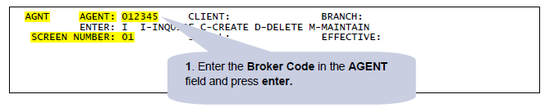
2 | Validate the AGENT NAME on the AGNT screen, if the same on the request (do CAMS lookup and check SIN)  - Make sure the Garnishee is set to Y (if already set to N- no action required)  - N = Broker is not being garnished.  - Y = Broker is being garnished.  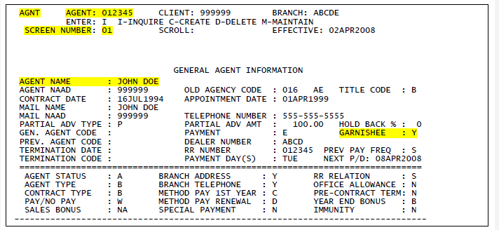
3 | Change the SCREEN NUMBER field to 02 and press enter.  Take a screen of AGNT 02 before modifying any information and paste into a word document.
4 | ​In the ENTER field type M and press enter:  - I = Inquire (Default, to view information on an existing client)  - M = Maintain (To change or add information on existing client)  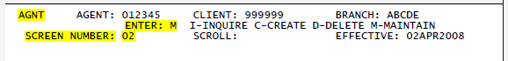
5 | ​PROCESS/FREQUEN: Change the Y to N and press enter.  **Note:  - The screen should now show no values in the GARNISHEE # 1 fields.  - GARNISHEE Field on AGNT 01 will have reverted to N automatically.  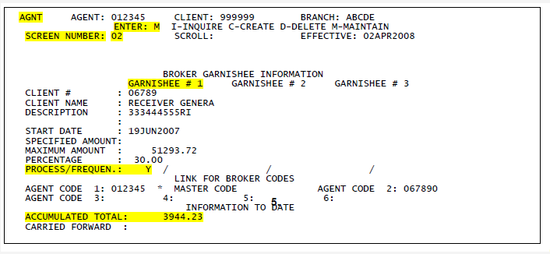
6 | Take another screen shot of AGNT 02 once the changes have been recorded and paste into the same world document.  - Save the doc and attach to your CSD in AWD.
7 | Reply to DS Contracting and confirm the release.
8 | ​Finalize case in AWD:  - Attach confirmation email to CSD.  - Add comment: “Release garnishee.”  - Ensure at least advisor First Name, Last Name, SL Code and Branch Code are completed.  - Change status of CSD to PROCESSED.  - If you have more than 1 SL code, create a briefcase and clone CSD to have 1 CSD per code.  - Attach screen shots.

Request for Information
It can happen that we receive a request for information regarding an existing or past garnishee. In this case, provide all possible details. Refer to AWD for past requests and Capsil for information currently on any code in question.

Creating a Garnishee Client Number (NAAD record)
**Note: most NAADs are on the list, search by the address in Excel sheet.
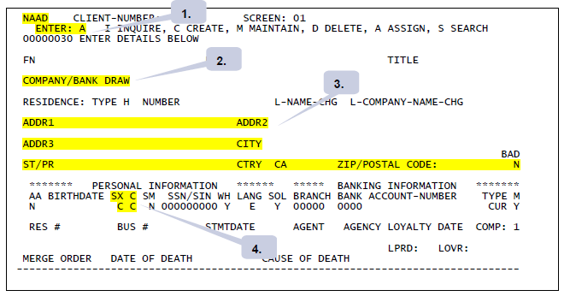
STEP | ACTION
1 | Access the NAAD Screen of Capsil  - In the ENTER field type A and press enter:  - I = Inquire (Default, to view information on an existing client)  - A = Assign (To assign a new NAAD number to a new)
2 | Enter the Name of the New Garnishee, as indicated on the request, in the Company/Bank Draw field.
3 | Enter the address of the New Garnishee as indicated on the request.
4 | In the SX Field enter C and in the C Field enter C.  Once the information for the New Garnishee has been entered press Enter.
5 | CAPSIL will then assign the next available sequential number as the new Client (NAAD) Number for the New Garnishee.  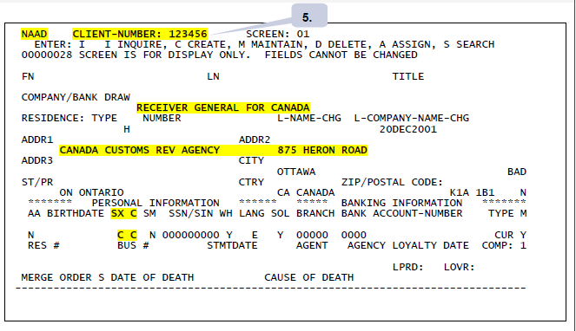  - Write down the new NAAD number that has been assigned.
6 | Update the NAAD Listing for Garnishee file (Lifeinsu/Commissions/Garnishee folder/NAAD Listing for Garnishees) with the New Garnishee information.
7 | ​Scroll up and proceed to follow instructions on Set-Up a New Garnishee.  **Note:  - A NAAD number must be created for any Garnishee that does not currently exist in the NAAD Listing for Garnishee file.  - Lifeinsu/Commissions/Garnishee Folder/NAAD Listing for Garnishees  - Once done, update this listing with the new details.

Advise DS of Incorrect/Missing Information
If required information is:
- Not provided.
- Incorrect.
- Unclear.
Contact the DS for clarification.
Once written confirmation (email or inter-office mail) has been received, then the request can be processed.

Release on CRO Capsil – Please send the request to Sr. Analyst (Antonietta D'Amato)
When the balance to the payee is over $50, a cheque is issued (DISB). In this example, CRA is paid 40% (30% was original rate) and the balance is paid to the agent.

Existing Garnishee path:
- I drive/Commissions/CRO Capsil/Garnishee Folder/Followup Garnishee
- When DS advises that a release has been received, the active worksheet is moved to the file “released”
- S:\611CRO\AGENCY\Garnishee\released then the agent code is put back on ‘Pay” and future payments will be sent to the agent if the balance is greater than $50.
- E-mails and any correspondence should be saved in AWD.
Alternate search options
Search on CRO Capsil using ALFI, enter the surname, first letter of first name* and check for any client numbers ending in ‘A” associated with a POLICY containing six digits.
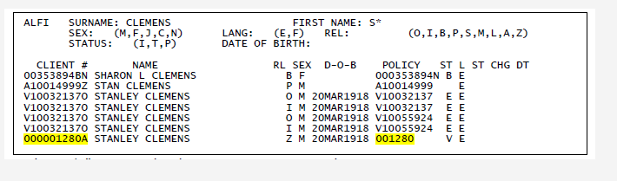

Appendix 7A: New Garnishee Set-Up – Specific amount instead of %
- Specific Amount Per Pay Period
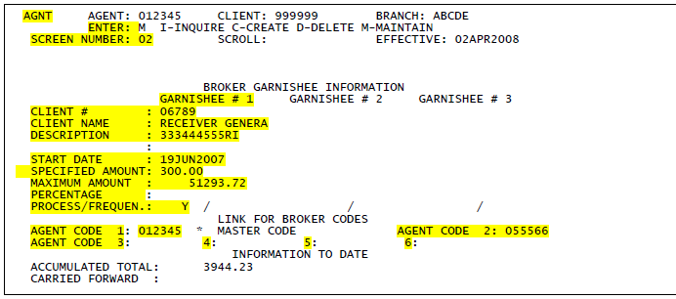

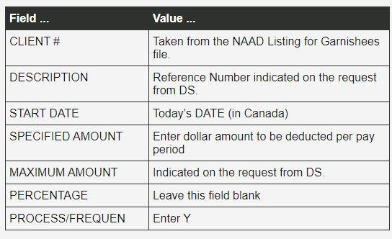

- Continue to process the New Garnishee Set-Up from Step 8 of the New Garnishee Set-Up steps (Scroll up).

Document History
Nov 2024: Updated by Kescia Lyn Marasigan

